LOT 1 – Conference Room Chairs (14 pcs)
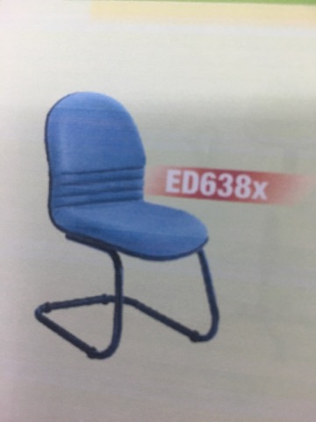

COLOR: BLACK

LOT 2 - Office Receiving Chair for RD ( 2 pcs)
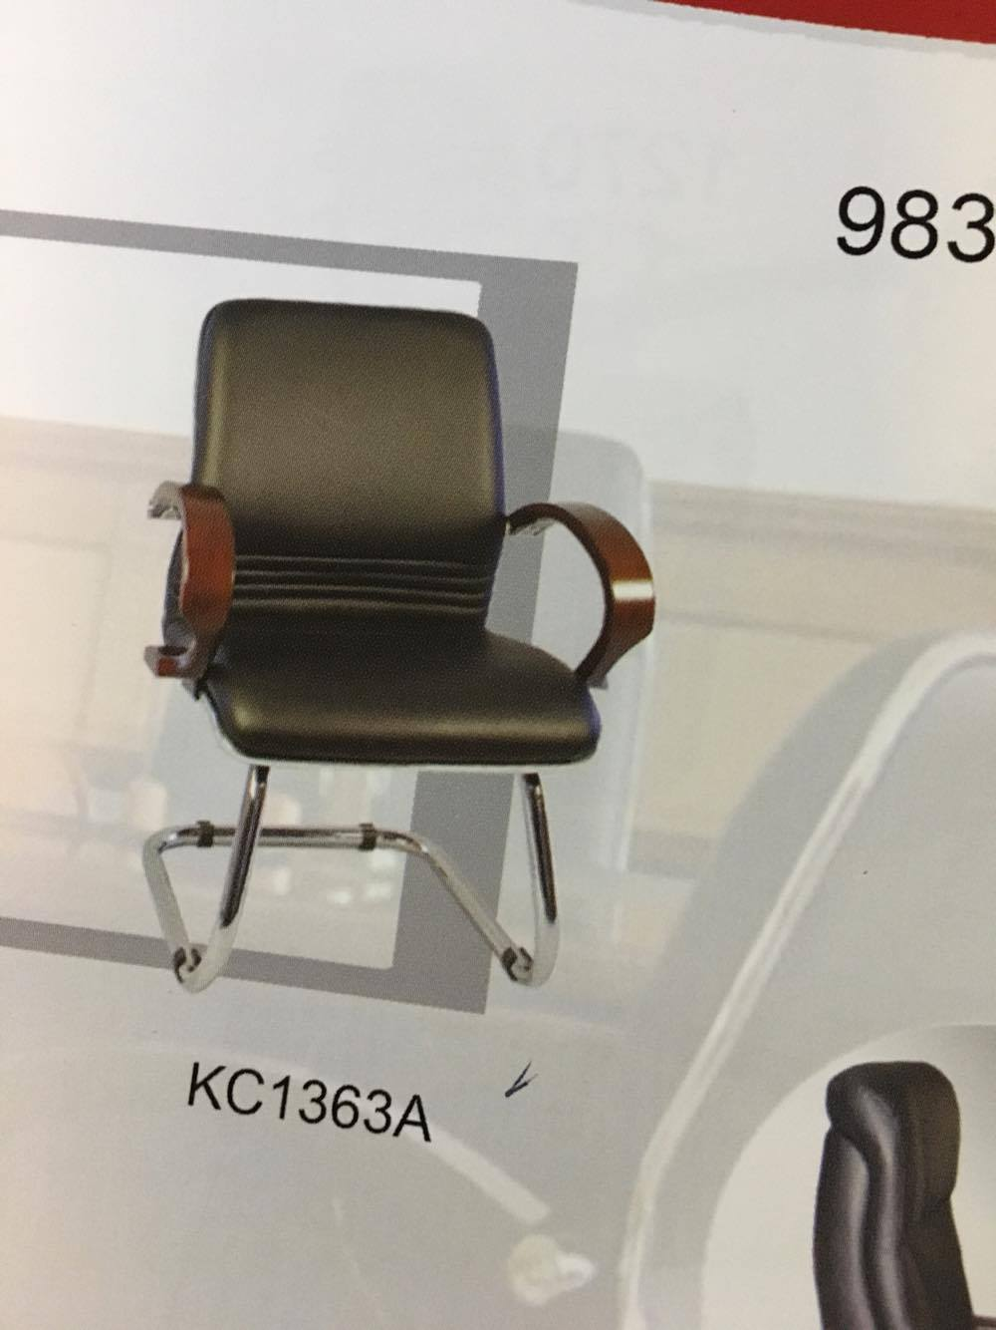

LOT 3 – Executive Chair for RD (1 pc.)

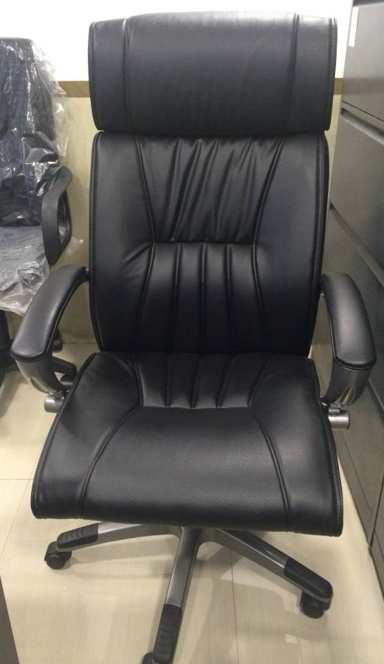

LOT 4 - Office Receiving Chair for Staff ( 23 pcs)
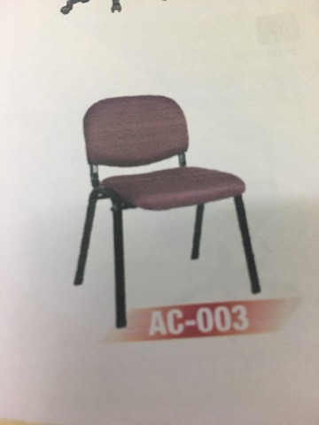

Color: BROWN

