Date: June 9, 2015
Quotation Number: 1

Project Reference # | 1506-01
Name of the Project | 2015 POPCEN
Location of the Project | PSA Misamis Occidental, Ozamiz City
REQUEST FOR QUOTATION

Company Name
Address
Please quote your lowest price on the 2015 POPCEN T-SHIRTS as specified below and submit your quotation duly signed by your representative not later than June 19, 2015.

JULITO F. PILAR
SBAC Chairman
General Conditions:
- The approved budget for the contract is Php 259,500.00
- All entries must be typewritten.
- Duration of Bidding within June 9 – June 19, 2015.
- PhilGEPS registration certificate shall be attached upon submission of the quotation.

Lot | Item and Description | Quantity | Unit Cost
A | 2015 POPCEN T-SHIRT  - * for hired Personnel (CAS/TS/ENs)  - * for PSA Personnel (P.O. & D.O. Clerks)  - See attachment H for prototype design for hired personnel and PSA personnel | 1710  10 | Php _150.00___  Php __300.00__
TOTAL AMOUNT
After having carefully read and accepted your General Conditions, I/we quote you on the item/s specified above.



________________________________
NAME OF FIRM

BY: ___________________________
Print Name & Signature

___________________________
Designation
For Census Hired Personnel: EN, TS, CAS, and all other hired POPCEN 2015 personnel
All white T-shirt with collar
With Philippine Statistics Authority (front of t-shirt) and POPCEN 2015 logo and slogan (back of t-shirt)
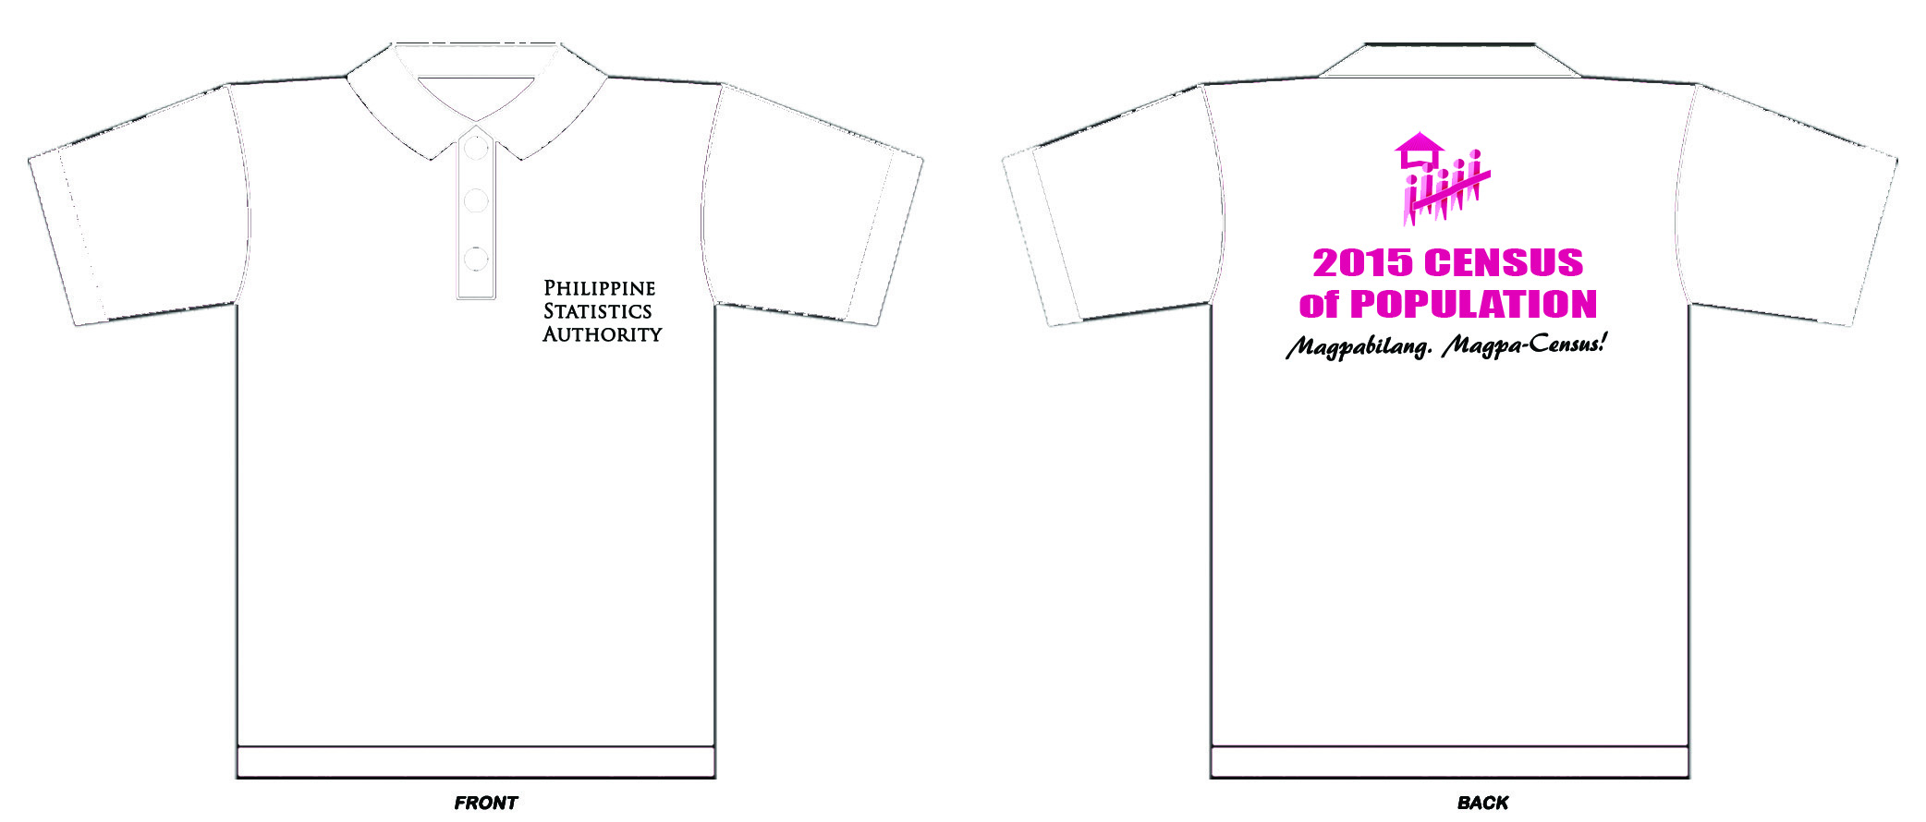

Black font
Font type: Trajan Pro
All white

Fuchsia font; Font type: IMPACT
Fuchsia

Black font; Font type: AR BERKLEY

For PSA Employees
Pink and Gray T-shirt with collar (gray color: sleeves, collar, placket; pink other parts of t-shirt)
With Philippine Statistics Authority (front of t-shirt) and POPCEN 2015 logo and slogan (back of t-shirt)

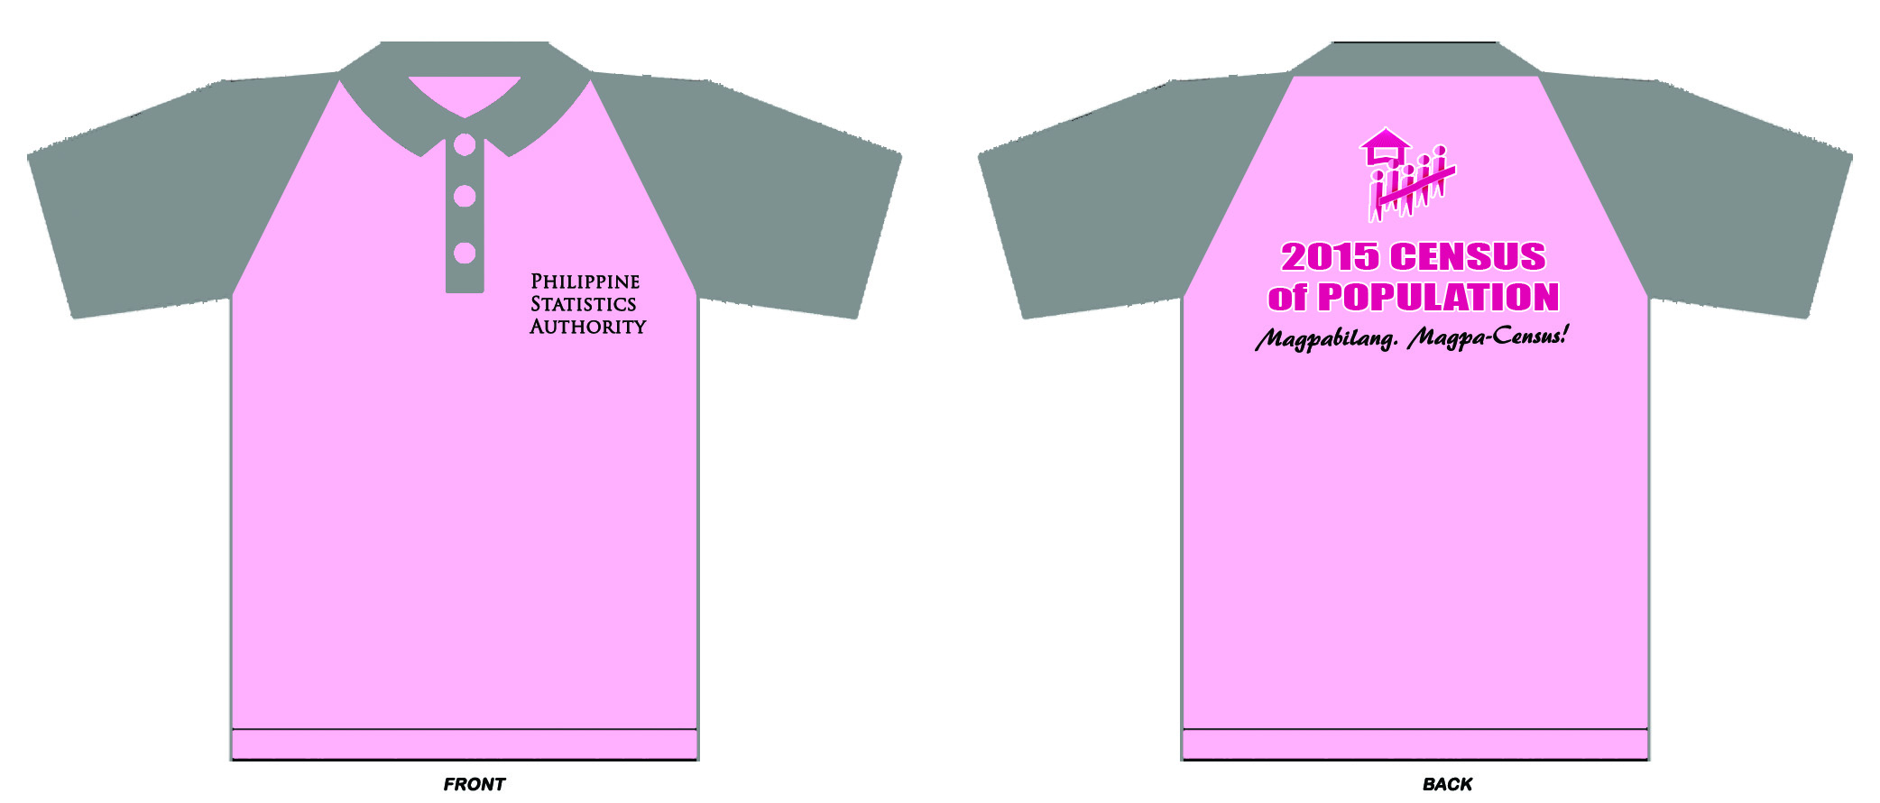
Collar in gray
Sleeves in gray
Placket front center in gray
Black font
Font type: AR BERKLEY
Black font; Font type: Trajan Pro
Fuchsia font with white font outline
Font type: IMPACT
Pink
Dark and light fuchsia with white outline

