PHILIPPINE STATISTICS AUTHORITY
Regional Statistical Services Office 7, Cebu City
REQUEST FOR QUOTATION

BID FORM

Qty.  50  2  2  2  2  6  3  4  5  2  20  32  4  10  4  10  10  10  5  100  3  1  6  1  30  10  20  20  20  30  50  50  3  1  2  10  10  2  2 | unit  bottle  pc  pc  pc  pc  pc  pc  pc  pc  pack  pack  pc  pc  pack  pc  pc  pc  pc  pc  pc  pc  pc  pc  pc  pc  pc  pc  pc  pc  pc  pc  pc  pc  unit  pc  box  box  pc  pc | Item/s and specification/s (minimum)  Ink, 20 ml, for self-inking  stamp  Pre-inked/self-inking stamps,  customized, ONE STOP  SHOP FOR OFW,  approximate size: 9.5cm x  3.10cm (see attached  layout – layout # 1)  Pre-inked/self-inking stamps,  customized,  AUTHENTICATION  approximate size: 6cm x  10cm (see attached  layout – layout # 2)  Pre-inked/self-inking stamps,  customized, REPUBLIC  OF THE PHILIPPINES,  PHILIPPINE STATISTICS  AUTHORITY, OFFICE OF  THE CIVIL REGISTRAR  GENERAL W/ PSA-CRS  LOGO (for authentication),  approximate size: 9.5cm x  1.90cm (see attached  layout – layout # 3)  Pre-inked/self-inking stamps,  customized, DATE  VERIFIED (for  authentication),  approximate size: 8.2cm x  3.80cm (see attached  layout – layout # 4)  Pre-inked/self-inking stamps,  customized,  SIGNATORIES (for  authentication),  approximate size: 5cm x  1.2cm (see attached  layout – layout # 5)  Pre-inked/self-inking stamps,  customized, RECEIVED W/  PHILIPPINE STATISTICS  AUTHORITY,  approximate size: 4.5cm x  4.5cm (see attached  layout – layout # 6)  Pre-inked/self-inking stamps,  customized, RELEASED,  approximate size: 4.5cm x  4.5cm (see attached  layout – layout # 7)  Presenter, OS support:  Windows 7, Windows 8,  Windows 10; Working  Distance:10m standard;  Wireless Technology:  2.4GHz  Notarial Seal #24, size: 54mm  (2-1/8”), gold, 10  boxes/pack  Page marker, stick-on, ½”x2”,  100 sheets/pad, 5  pads/pack, assorted  color  Battery, C size, rechargeable,  2500 milli amps.  Battery charger for C size (can  charge 4 batteries)  Battery AA, rechargeable,  2800 milli amps, 2s/pack  Battery charger for AA, AAA &  9 volts battery  Binder, ring binder, ¼”, plastic  Binder, ring binder, ½”, plastic  Binder, ring binder, ¾, plastic  Binder, ring binder, 1”, plastic  Box, corrugated/collapsible,  continous cover, with  hand holes, brown  Calculator, large display, 2-  way power (battery &  solar), 12-digit, tilt  display  Calling card box with divider  Cash box, approximate  dimension:  3.5”x7.8”x6.3” (medium)  Cash box, big  Data file box w/ separate cover  for legal size (long)  documents, good quality  Eraser for pencil, good quality  Folder, long, expanded,  orange  Folder, long, expanded, violet  Folder, long, expanded, yellow  Folder, long, ordinary, blue  Folder, long, ordinary, yellow  Folder, long, ordinary, kraft  Shopping bag/sacko bag with  zipper, extra large size  Paper cutter, 18”x15”, metal  Base  Puncher, 7 cm punch hole  distance: punches up to  50 sheets, robust  construction, rubber  protection pads, handle  lock, automatic centering  gauge up to 50 sheets  Rubberband, 3” diameter,  round, 350g  Rubberband, 4”, diameter,  round, 350g  Stapler, heavy duty, with 100  sheets or more capacity  Scientific calculator,  solar/battery, non-  programmable, 605  function, up to 18 digits,  display screen size 61 x  25mm), 7-minute auto  power off, body size (171 x  86 x 17.3mm) with cover,  textbook display scientific  Note:  - Please provide samples or pictures or specify the brand of the item being offered.  - With sample pictures attached.  - Please indicate also the DATE OF DELIVERY.  - Deadline for submission of quotation is on or before November 14, 2016, 5:00 p.m.  - For clarifications, kindly contact Irish B. Velasco @ 412-6794 / 256-0592. You may also send your quotation or offer to this email address: psa07.rsso@gmail.com or thru fax no. 412-6794) | Unit Price | Total Amount  (VAT inclusive)  Total amount in words:___________________  ________________________________________________________________________

After having carefully read and accepted your Terms and Conditions. I/We quote you on the item at prices noted above.

Printed Name of authorized representative/Signature____________________________

Position: __________________________

Name of Company: ______________________________________________________

TIN #: ____________________________ (Please specify if VAT or NON-VAT)

Address: _____________________________Email Address:___________________

Fax No. _________________________

Cellphone No.: ___________________ Tel No.__________________________

Date: ___________________________

SAMPLE PICTURES

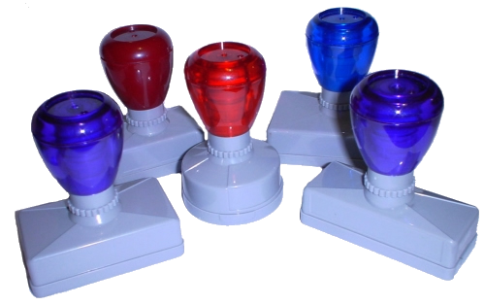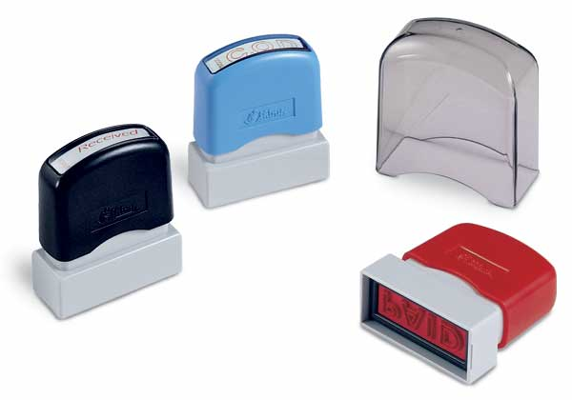

PRE-INKED/SELF-INKING STAMPS, CUSTOMIZED

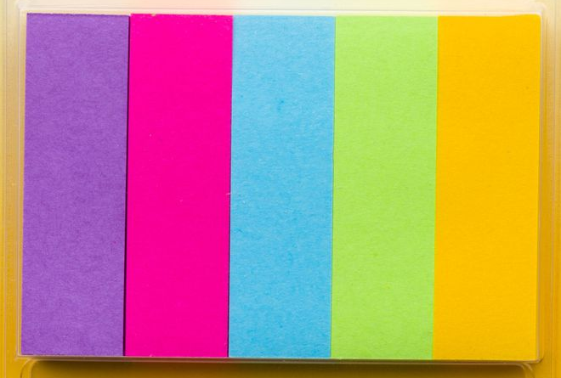
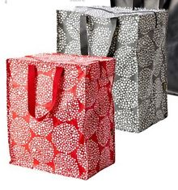
SHOPPING BAG/ECO BAG WITH ZIPPER
PAGE MARKER, STICK-ON

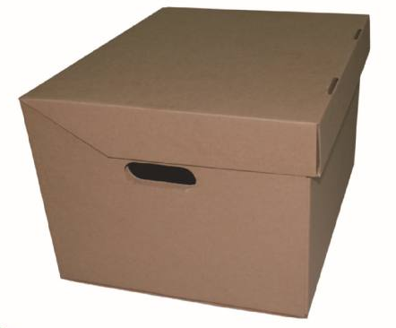
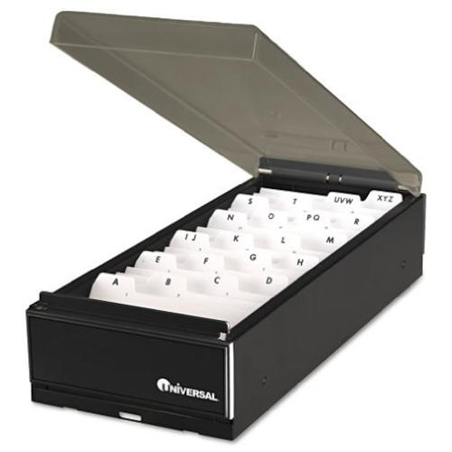

COLLAPSIBLE BOX CALLING CARD BOX W/ DIVIDER
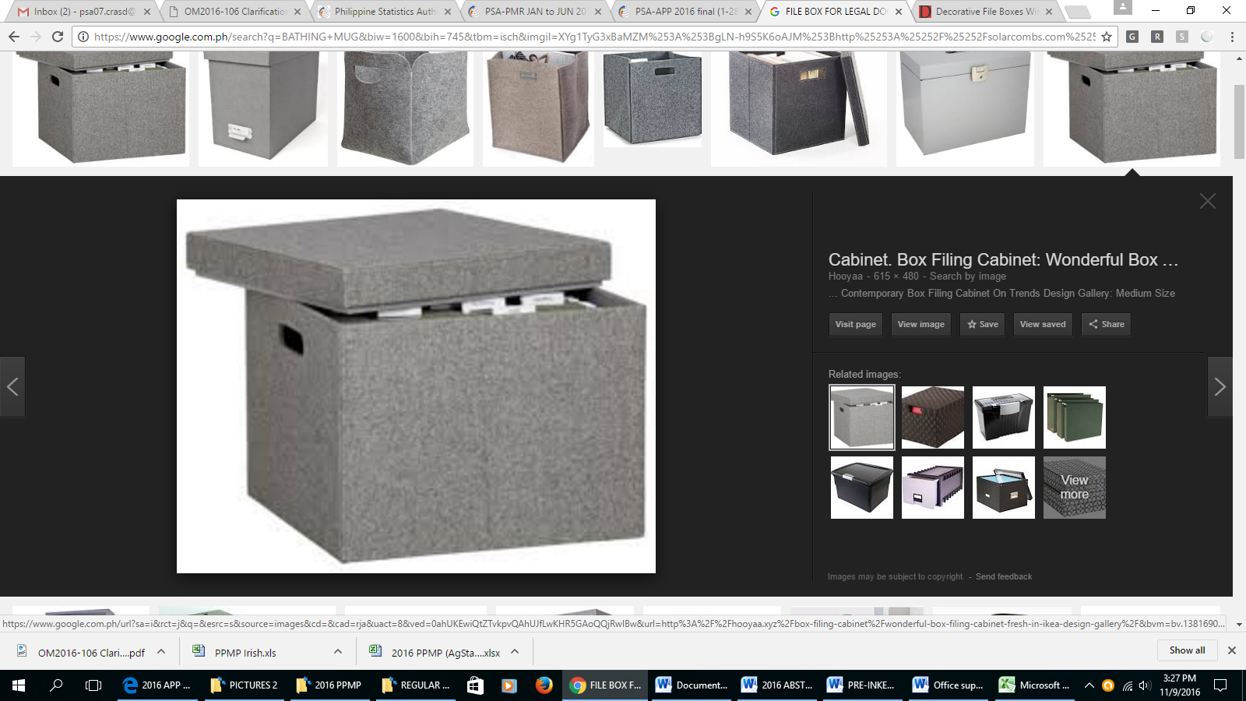
DATA FILE BOX WITH SEPARATE COVER

PRE-INK STAMPS LAYOUT

Layout # 1 – ONE STOP SHOP FOR OFW


ONE STOP SHOP FOR OFW
Date Received: ____________________________
Screened by: ______________________________

Layout #2 - AUTHENTICATION
THIS IS TO CERTIFY THAT THIS DOCUMENT WAS ISSUED BY A LOCAL CIVIL REGISTRY PERSONNEL WHO IS AUTHORIZED TO ISSUE THE SAME AND WHOSE AUTHORITY WAS CONFIRMED BY THE CIVIL REGISTRAR GENERAL AND THAT THE SIGNATURE OF THE SAME LOCAL CIVIL REGISTRY PERSONNEL WHICH APPEARS ON THE DOCUMENT IS SIMILAR TO THE SIGNATURE SPECIMEN OFFICIALLY SUBMITTED TO AND FILED WITH THIS OFFICE.

Layout #3 – REPUBLIC OF THE PHILIPPINES, PHILIPPINE STATISTICS AUTHORITY, OFFICE OF THE CIVIL REGISTRAR GENERAL W/ PSA-CRS LOGO

Republic of the Philippines
Philippine Statistics Authority
OFFICE OF THE CIVIL REGISTRAR GENERAL

Layout #4 – DATE VERIFIED (FOR AUTHENTICATION)

DATE VERIFIED _________________________________

VERIFIED BY ___________________________________

FOR THE CIVIL REGISTRAR GENERAL

Layout #5 – SIGNATORIES (FOR AUTHENTICATION) – 1 PC. EACH SIGNATORY

RONALDO C. TAGHAP
REGIONAL DIRECTOR

ENGR. LEOPOLDO P. ALFANTA JR.
CHIEF STATISTICAL SPECIALIST

HERA B. JUAREZ, DPA
REGISTRATION OFFICER IV

ENGR. FELIXBERTO M. SATO JR.
SENIOR STATISTICAL SPECIALIST

EVELYN L. PATRIARCA
ADMINISTRATIVE OFFICER IV

JUNETTE O. CABRERA
ADMINISTRATIVE OFFICER III

Layout #6 – RECEIVED W/ PHILIPPINE STATISTICS AUTHORITY
Philippine Statistics Authority
RSSO VII, Cebu City

By: ___________________
E C E I V E
R
D

Layout #7 – RELEASED

Philippine Statistics Authority
RSSO VII, Cebu City

By: ___________________
E L E A S E
R
D

