PHILIPPINE STATISTICS AUTHORITY
Regional Statistical Services Office 7, Cebu City
REQUEST FOR QUOTATION

BID FORM

Qty.  10  10  15  10  10  10  4  25  15  2 | unit  pc  pc  pc  pc  pc  pair  pc  pc  pc  pc | Item/s and specification/s (minimum)  Air purifier and humidifier  Air purifier, refill, 60 ml  Bathing mug with handle/water  dipper, medium size, good  quality  Cotton duster, good quality  Doormat, PVC outdoor rubber  coil mat, non-slip  Gloves for utility, all-purpose,  large, latex  Trash bin, rolling with cover,  120 L  Trash bin, swing cover, 8 ltrs.  Trash bin, swing cover, 15 ltrs.  Trash bin, swing cover, 25 ltrs.  Note:  - Please provide samples or pictures or specify the brand of the item being offered.  - With sample pictures attached.  - Please indicate also the DATE OF DELIVERY.  - Deadline for submission of quotation is on or before November 14, 2016, 5:00 p.m.  - For clarifications, kindly contact Irish B. Velasco @ 412-6794 / 256-0592. You may also send your quotation or offer to this email address: psa07.rsso@gmail.com or thru fax no. 412-6794) | Unit Price | Total Amount  (VAT inclusive)  Total amount in words:___________________  ________________________________________________________________________

After having carefully read and accepted your Terms and Conditions. I/We quote you on the item at prices noted above.

Printed Name of authorized representative/Signature____________________________

Position: __________________________

Name of Company: ______________________________________________________

TIN #: ____________________________ (Please specify if VAT or NON-VAT)

Address: _____________________________Email Address:___________________

Fax No. _________________________

Cellphone No.: ___________________ Tel No.__________________________

Date: ___________________________

SAMPLE PICTURES

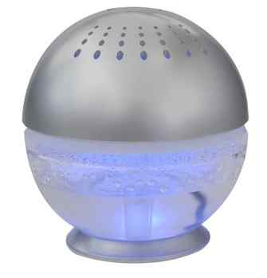
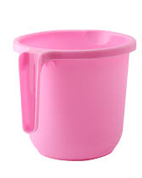
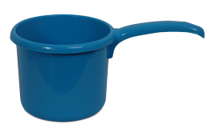
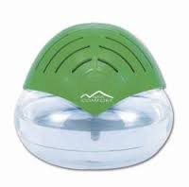
AIR PURIFIER/HUMIDIFIER
BATHING MUG/WATER DIPPER
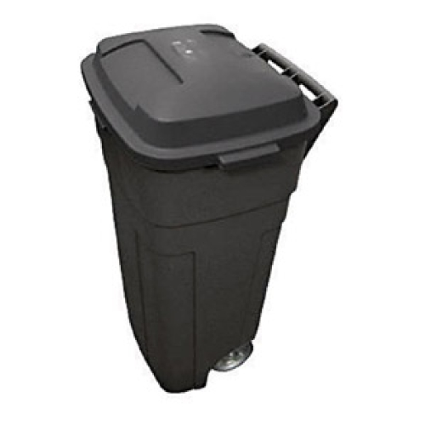

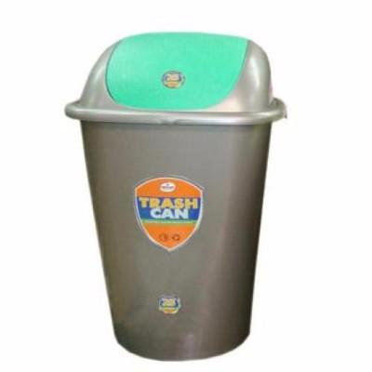
DOORMAT, PVC OUTDOOR RUBBER COIL MAT, NON-SLIP
TRASH BIN, ROLLING, WITH COVER
TRASH BIN, SWING COVER

