

Republic of the Philippines
Philippine Statistics Authority
Regional Statistical Services Office XI

INVITATION TO BID FOR THE PROCUREMENT OF EQUIPMENT,
SUPPLIES AND MATERIALS FOR THE 2015 CENSUS OF POPULATION

Invitation to Bid No. 2015-3

- The Philippine Statistics Authority – Regional Statistical Services Office XI (PSA-RSSO XI), through the General Appropriations Act of 2015 and/or continuing appropriation, intends to apply the sum of FOUR MILLION NINE HUNDRED FORTY THREE THOUSAND SIX HUNDRED FIFTY NINE PESOS AND FIFTY CENTAVOS (PhP4,943,659.50) ONLY being the Approved Budget for the Contract (ABC) to payments under the contract for purchase of equipment, supplies and materials for the 2015 Census of Population (2015 POPCEN). Bids received in excess of the ABC shall automatically be rejected at bid opening.

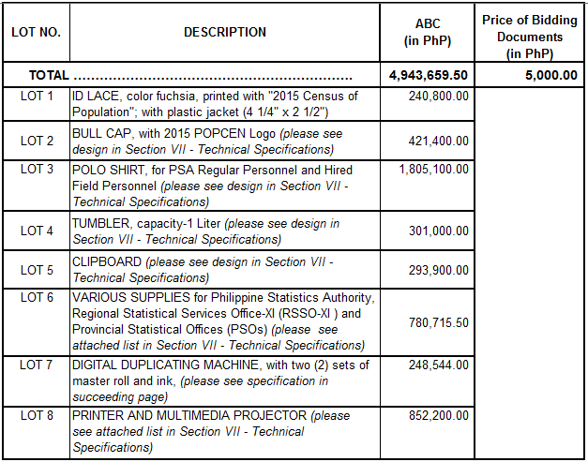

- The PSA-RSSO XI now invites bids for the procurement of equipment, supplies and materials for the conduct of the 2015 POPCEN. Delivery of the goods is required as indicated in the Schedule of Requirements. Bidders should have completed, within three years from the date of submission and receipt of bids, a contract similar to the Project. The description of an eligible bidder is contained in the Bidding Documents, particularly, in Section II. Instructions to Bidders.

- Bidding will be conducted through open competitive bidding procedures using a non-discretionary “pass/fail” criterion as specified in the Implementing Rules and Regulations (IRR) of Republic Act (RA) 9184, otherwise known as the “Government Procurement Reform Act”.

Bidding is restricted to Filipino citizens/sole proprietorships, partnerships, or organizations with at least sixty percent (60%) interest or outstanding capital stock belonging to citizens of the Philippines, and to citizens or organizations of a country the laws or regulations of which grant similar rights or privileges to Filipino citizens, pursuant to RA 5183 and subject to Commonwealth Act 138.

- Interested bidders may obtain further information from the Regional Bids and Awards Committee (RBAC) Secretariat between 8:00 am and 5:00 pm.

A complete set of Bidding Documents may also be acquired by the interested bidders from May 12, 2015 and onwards prior to the bid opening from the RBAC Secretariat upon payment of a nonrefundable fee (pursuant to the latest Guidelines issued by the GPPB) in the amount of Five Thousand Pesos (PhP5,000.00).

The method of payment shall be either in cash or manager’s check (payable to PSA-RSSO XI).

It may also be downloaded free of charge from the website of the Philippine Government Electronic Procurement System (PhilGEPS) and the website of the Procuring Entity, provided that Bidders shall pay the nonrefundable fee for the Bidding Documents not later than the submission of their bids.

- A pre-bid conference open to all interested parties shall be conducted on May 22, 2015 / 1:30 PM at the Conference Room of the PSA-RSSO XI located in Ango Building, JP Cabaguio Avenue, Davao City. At most two representatives from each prospective bidder shall be allowed to attend the pre-bid conference. Additionally, only those who have purchased the bidding documents can raise questions.

Furthermore, interested bidders shall bring samples with them during the pre-bid conference. For the equipment, interested bidders shall bring pictures or brochures.

- Sealed bids may be delivered to the address stated below within June 2, 2015 to 1:15PM of June 8, 2015. All Bids must be accompanied by a bid securing declaration and at least one of any of the acceptable forms and in the amount stated in ITB Clause 18.

Bid opening shall be on June 8, 2015 at 1:30PM at the Conference Room of the PSA-RSSO XI. Bids shall be opened in the presence of the Bidders’ representatives. Late bids shall not be accepted.

- The PSA-RSSO XI reserves the right to accept or reject any bid, to annul the bidding process, and to reject all bids at any time prior to contract award, without thereby incurring any liability to the affected bidder or bidders.

- For further information, please refer to:

RENANTE B. MATURAN
Head of the Secretariat
Regional Bids and Awards Committee (RBAC)
Philippine Statistics Authority (PSA)
Regional Statistical Services Office XI (RSSO XI)
Ango Building, JP Cabaguio Avenue, Davao City
Telephone Number: (082) 221-8338
Telefax Number: (082) 226-4759
Email Address: nsoxi@pldtdsl.net

PEPITO D. AMOYEN (SGD)
RBAC Chairperson
PSA-RSSO XI

