Bid Bulletin Ref. No. | Specific Page/Section in the Bidding Docs. | Query/Issue | BAC Response/Clarification
BB1-1 | Page 10,  Section I  Invitation to Bid |  | Item No. 6 –  The PSA-BAC will hold a Pre-Bid Conference on 19 June 2017, 10:30 AM, at the FAS Training Room, 11/F Eton CentrisCyberpod One, EDSA cor. Quezon Ave.,Diliman, Quezon City, which shall be open to prospective bidders.  Item No. 7 –  Bids must be duly received by the BAC Secretariat at the PSA Conference Room, 17/F Eton CentrisCyberpod Three, EDSA, Diliman, Quezon City on or before 03 July 2017, 10:30 AM. All Bidsmust be accompanied by a Bid Security in any of the acceptable forms and in the amount stated in ITB Clause 18.  Items No. 8 –  Activities Venue  Pre-Bid Conference FAS Training Room, 11/F Eton CentrisCyberpod One, EDSA cor. Quezon Ave., Diliman, Quezon City  Submission and Opening of Bids Submission before the date of opening : BAC Secretariat, 11/F Eton CentrisCyberpod One, EDSA cor. Quezon Ave., Diliman, Quezon City Submission on the date of opening on or before 10:30 AM: PSA Conference Room, 17/F Eton CentrisCyberpod Three, EDSA, Diliman. Quezon City
Bid Bulletin Ref. No. | Specific Page/Section in the Bidding Docs. | Query/Issue | BAC Response/Clarification
BB1-2 | Page 50,  Section III  Bid Data Sheet |  | ITB Clause 5.4:  The bidder must have completed, within the period specified in the Invitation to Bid and ITB Clause 12.1(a)(ii), a single contract similar to this Project, equivalent to at least fifty percent (50%) of the ABC.
BB1-3 | Page 87  Section VII  Technical Specifications |  | “ITB Clause Error! Reference Code not found, and/or GCC Clause ii” should be "...subject to the provisions of ITB Clause 3.1(a)(ii) and/or GCC Clause 2.1(a)(ii).
BB1-4 | Page 87  Section VII  Technical Specifications | Can you provide us the revised specifications of the publications and the layout of the back cover with pocket? | Revised Specifications:  Materials:  - Cover stock  - C2S220 lbs.  - full color with matte lamination and spot UV  - IFC (Inside front cover)  - plain white, no print  - Inside pages  - C2S 80 lbs.  - full color  - IBC (inside back cover)  - with pocket (die cut and pasted in the center) for USB card type flash drive  - Size: 8.5" x 11"  - Binding: Perfect (Hot melt/Smythe sewn)  - Process: Offset printing  - CD/Artwork supplied  - Dimensions as follows:  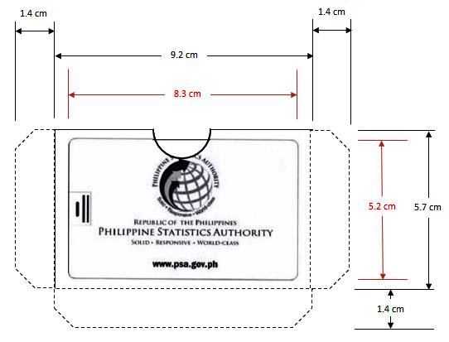  (Pls. refer to attached sheet)
BB1-5 | Page 87  Section VII  Technical Specifications | Can you provide us the estimated number of pages per edition? | - Estimated no. of pages/volume excluding cover  Estimated No. of Pages  Philippines 80  NCR 72  CAR 74  Region I 72  Region II 72  Region III 75  Region IVA 72  Region IVB 74  Region V 74  Region VI 74  Region VII 72  Region VIII 75  Region IX 74  Region X 74  Region XI 74  Region XII 74  Caraga 74  ARMM 74  NIR 72  Amendment to order:  Any increase or decrease in the number of pages shall be adjusted in the amount proportionately. But the increase or the cumulative amount not exceed ten (10%)percent of the original contract price.
BB1-6 | Page 84  Section VI  Schedule of Requirements | Can the delivery date be thirty (30) calendar days after receipt of final proofing instead of thirty (30) days upon receipt of Notice to Proceed? | The delivery date will be thirty (30) calendar days upon receipt of Notice to Proceed.
BB1-7 |  |  | Checklist of Requirements shall be provided.

